freETarget
Application Note: Multilane Targets

SUMMARY
This application note describes the steps needed to install multiple targets side-by-side in a single shooting range. The steps are:
- Give the target a name
- Put the target onto the home WiFi
- Assign an IP address
- Change the trip point to avoid spurious shots
- Calibrating the target

REQUIRED
- ESP32 Firmware Version 6.0.0 or higher
- freETarget PC software

SETUP
The target needs to be connected to the PC using a USB cable. Once configuration is complete, the USB can be removed, and the target will operate over WiFi.
- Connect the target to the PC with a USB cable
- Launch the PC client program
- Connect to the target
- Open the ESP32 terminal (from the Debug icon, red fingerprint, upper right)
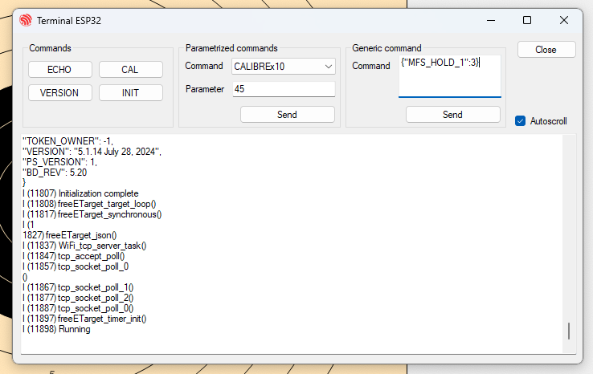

ASSIGN A TARGET NAME
Each target can be assigned a name so that it is easily identified later.
In the Generic Command field, enter the command
{“NAME_ID”:x} where X is the name ID. The list of
0 – FET-TARGET. (Default)
1 – FET-1  2 – FET-2  3 – FET-3  4 – FET-4  5 – FET-5  6 – FET-6  7 – FET-7  8 – FET-8  9 – FET-9  10 – FET-10 | 11 – DOC  12 – DOPEY  13 – HAPPEY  14 – GRUPMY  15- BASHFUL  16 – SNEEZY  17 - SLEEPY | 18 – RUDOLF  19 – DONNER  20 – BLITZEN  21 – DASHER  22 – PRANCER  23 – VIXEN  24 – COMET  25 – CUPID  26 - DUNDER | 27 – ODIN  28 – WODEN  29 – THOR  30 - BALDAR
Using a NAME_ID of 99 allows the operator to assign a new name to the target.
{“NAME_ID”:99. “NAME_TEXT”:”MyNewTarget”}

PUTTING THE TARGET ON THE HOME NETWORK
When operating multiple targets on WiFi the default mode: Access Point will cause interference between the targets and result in intermittent operation. The solution to this is to put the target onto the home network and let the router take care of assigning frequencies and operation.
This is done by identifying the SSID to be connected to and use the WiFi password if required.
{“WIFI_SSID”:”HomeNetwork”, “WIFI_PWD”:”password”, “ECHO”:0}
If the home network is open, i.e. no password is required, then use
{“WIFI_SSID”:”HomeNetwork”, “WIFI_PWD”:””, “ECHO”:0}

The last command “ECHO” will cause the target to display the current settings. Look for the setting
WIFI_IP_ADDRESS: aaa.bbb.ccc.ddd
This will show the IP address that has been assigned by the router.
Record this number for later use _________________

ASSIGNING A STATIC IP ADDRESS
The router will assign an IP address to the target. More-often-than-not, the IP address will change every time the target connects to the network. To get around this problem, the target can be assigned a static IP address.
Using the IP address recorded above, or another on the same network, use the command
{“WIFI_IP”:”IP address”, “WIFI_GATEWAY”:”gateway”}
Where IP address is of the form 192.168.1.99 using the number above as an example
Gateway is of the form 192.168.1.1 as determined by your router
Reboot the target for the settings to be forced into the hardware.

SETTING THE TRIP POINT
When used in a crowded shooting range, the noise from one target will often be picked up by the adjacent one. To avoid the problem, the sound trip point can be changed using the command:
(“VREF_LO”:3.0, “VREF_HI”:4.5}
This will make the target more immune to stray sounds.
The value of VREF_LO can be as high as 4.3 Volts if needed.

CALIBRATING THE TARGET
When operating alone, the calibration constants are stored in the PC. However this means that if the shooters bring their own PCs with them, then the calibration will need to be done every time a new PC is connected to the target. Starting in Version 6.0, the calibration constants can be stored in the target so that the PC client can be switched between targets.
- Connect to the target as you would normally
- Use a conventional target with scoring rings
- Shoot five shots into the target, fairly well spaced
- Open the calibration icon (Upper right, small cross-hairs)
- The Calibration dialog box will appear
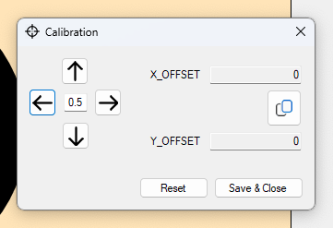
- Reset the calibration.
- Using the four arrows, adjust the shots on the screen to align with the shots on the paper
- Press the copy button (two overlapping squares)
- X out of the calibration screen,. Do not press Save & Close
- Return to the Diagnostics Terminl
- Paste the calibration settings into the Generic Command Box
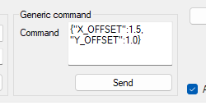
- Press SEND
This will save the calibration into the target for the next shooter.

